AARTI STEELS Ltd.
Bar Detection & Counting System

Powered by SPEAR AI Vision Platform

USER MANUAL

Rolling Mill Production — Operator & Supervisor Reference

Version | 2.0
Issued | 02 April 2026
Classification | Internal Use

Table of Contents
Table of Contents 2
1. Introduction 4
1.1 Purpose of this Manual 4
1.2 Intended Audience 4
1.3 System Architecture Overview 4
2. Module A — Bar Detection & Counting HMI 6
2.1 Accessing the Interface 6
2.2 Status Bar 6
2.3 Live Detection Feed 7
2.4 Sleep Mode 7
2.5 Heat & Line Control Panel 7
2.5.1 Summary Counters 8
2.5.2 PP3 Heat Queue 8
2.6 Starting a Heat 8
2.7 Stopping a Heat 9
2.8 Capture Frame 9
2.9 Reports & Data Export 9
3. Module B — Bar Counter Operator Entry 10
3.1 Accessing the Interface 10
3.2 Shift Summary Bar 10
3.3 Creating a New Heat Entry 10
3.3.1 Heat Identity 10
3.3.2 Bloom & Bar Details 11
3.3.3 Production Quantities 11
3.3.4 Mill Calculations (Auto-Calculated) 12
3.4 Saving a Heat Entry 12
3.5 Editing an Existing Heat Entry 13
4. Module C — Rolling Mill Production Report 14
4.1 Accessing the Report Module 14
4.2 Loading a Report 14
4.3 Report Summary Badges 14
4.4 Production Report Table 15
4.5 Exporting the Report 16
4.5.1 Download to Excel 16
4.5.2 Print or Save as PDF 16
5. Troubleshooting 17
5.1 Bar Count is Not Incrementing 17
5.2 Database Shows Disconnected 17
5.3 Heat Not Appearing in PP4 Queue After Entry 17
5.4 System Stuck in Sleep Mode 17
5.5 Mill Calculations Not Updating 18
5.6 Report Shows No Data 18
5.7 Excel Download Not Working 18
6. Glossary of Terms 19
7. Quick Reference Card 21
7.1 Start-of-Shift Checklist 21
7.2 Per-Heat Workflow 21
7.3 End-of-Shift Actions 21

1. Introduction
The SPEAR Bar Detection & Counting System is an AI-powered vision platform deployed at Aarti Steels Ltd. to automate the counting and monitoring of rolled steel bars on the production line. The system combines real-time computer vision running on an NVIDIA Jetson edge computing device with a web-based Human Machine Interface (HMI) that allows operators and supervisors to manage production heats, track bar counts, and generate daily production reports.

1.1 Purpose of this Manual
This manual provides step-by-step operating instructions for the three main interfaces of the SPEAR system:
- Module A — Bar Detection & Counting HMI (PP4 Operator)
- Module B — Bar Counter Production Data HMI (Production Details Entry by PP3 operator)
- Module C — Rolling Mill Production Report

1.2 Intended Audience
This document is intended for:
- Mill Operators are responsible for monitoring the live detection feed and managing heat queues.
- Production Operators who enter heat and production data into the Operator Entry module.
- Shift Supervisors and Managers who generate and review production reports.

ℹ NOTE — System Access
Access to each module is role-based. Contact your system administrator if you cannot access a screen described in this manual.

1.3 System Architecture Overview
The SPEAR system consists of three tightly integrated components:

Field / Element | Description
Camera (Line Camera 01) | High-resolution industrial camera mounted above the PP4 conveyor line, capturing real-time video of passing steel bars.
NVIDIA Jetson HMI | Edge AI processor running the SPEAR detection algorithm, connected to line cameras and the local network.
Production Database | Shared database storing heat entries, bar counts, and production metrics, accessible by all three modules.
Web Browser Interface | Role-based HMI accessible from any authorized workstation on the plant network.

✔ TIP
The system processes video at the camera's native frame rate. The "Frame" counter visible in the Live Feed increments with each processed frame.

2. Module A — Bar Detection & Counting HMI
The Bar Detection & Counting HMI (also called the PP4 Operator or Jetson HMI) provides a real-time view of the detection camera feed, current heat information, rod speed, and the PP3 heat queue. It is the primary interface for line operators monitoring bar production.
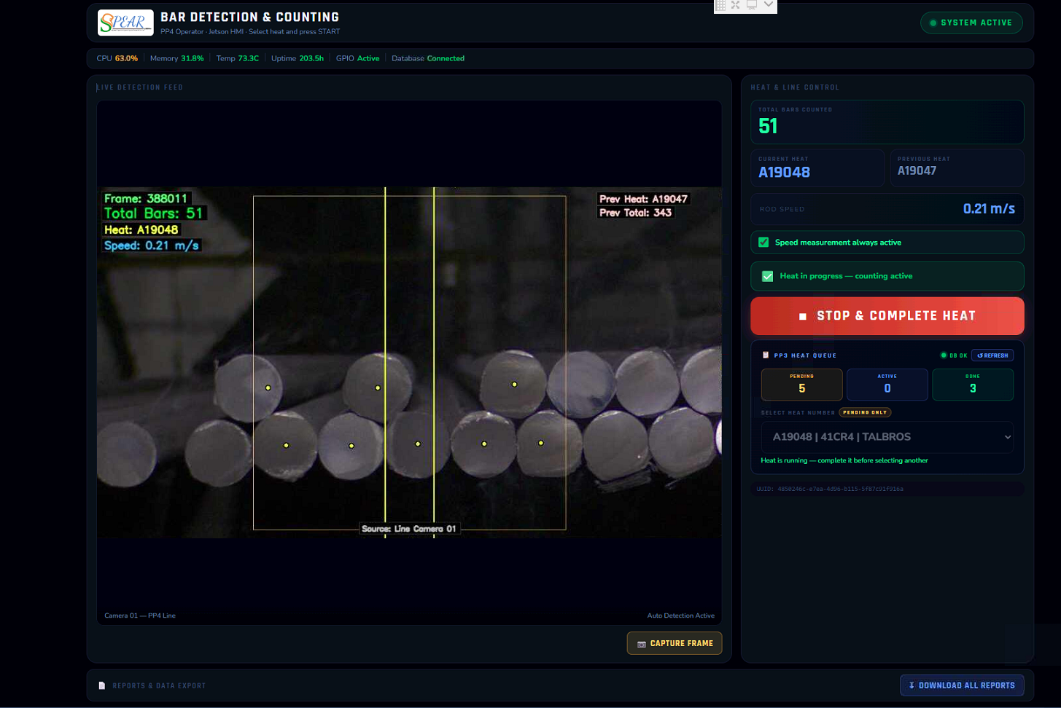
Figure 1 — Bar Detection & Counting HMI showing Sleep Mode with Heat A19047 and 343 total bars counted

2.1 Accessing the Interface
- Open a supported web browser (Google Chrome recommended) on the Jetson HMI workstation.
- Navigate to the plant-local URL provided by your system administrator (e.g., http://172.66.10.170:5000/).
- The interface loads automatically into the PP4 Operator view. No login is required on the Jetson terminal.

2.2 Status Bar
The dark header at the top of the screen displays real-time system health metrics:
Field / Element | Description
CPU % | Current CPU utilization of the Jetson device. Normal range: below 60%.
Memory % | RAM usage. Values above 80% may indicate performance degradation.
Temp (°C) | Jetson processor temperature. A reading above 85°C triggers a thermal warning.
Uptime | Time elapsed since the Jetson was last restarted, shown in hours.
GPIO | Status of the GPIO hardware interface used for hardware triggers. Should show Active (green).
Database | Connectivity to the PP3 production database. Must show Connected (green) for data to be saved.

⚠ WARNING — Database Disconnected
If the Database indicator shows Disconnected (red), bar counts are NOT being saved to the production database. Alert your IT administrator immediately before continuing production.

2.3 Live Detection Feed
The main dark panel occupies the majority of the screen and shows the live camera feed from Line Camera 01. Overlaid on the feed are real-time telemetry values:
Field / Element | Description
Frame | Sequential frame number processed by the AI engine since last restart.
Total Bars | Running count of bars detected in the current heat.
Heat | Heat number currently being processed (e.g., A19047).
Speed | Instantaneous speed of the rod/bar on the conveyor in meters per second.
Prev Heat / Prev Total | Heat number and bar count from the immediately preceding heat.

Two vertical yellow guidelines are superimposed on the video feed. These represent the detection zone boundaries. Bars crossing these lines are counted by the AI algorithm.

ℹ NOTE — Detection Zone
Do not obscure or move the camera. The detection zone lines are calibrated during system commissioning and must only be adjusted by a qualified SPEAR technician.

2.4 Sleep Mode
When no conveyor activity is detected for a configurable timeout period, the system enters Sleep Mode automatically. The feed overlay displays a Sleep Mode banner and the message "No conveyor activity detected."
Sleep Mode conserves system resources and prevents false counts during idle periods. The system wakes automatically when bar movement is detected by the speed sensor.

✔ TIP — Manual Wakeup
If the system does not wake automatically when production resumes, click the SLEEP MODE button in the top-right corner of the screen to toggle the system back to active monitoring.

Field / Element | Description
SLEEP MODE button | Shown in the top-right header. Toggles between active monitoring and sleep. Glows orange when active; dims when in sleep.

2.5 Heat & Line Control Panel
The right-hand panel is divided into two areas:

2.5.1 Summary Counters
Field / Element | Description
Total Bars Counted | Running total of all bars counted across all heats in the current shift/session.
Current Heat | Heat identifier currently loaded in the system (e.g., A19047).
Previous Heat | Heat identifier of the last completed heat.
Rod Speed | Live rod speed in m/s, updated every second.
Speed measurement always active | Green checkbox confirming that the speed sensor is operational regardless of whether a heat is active.

2.5.2 PP3 Heat Queue
The Heat Queue section shows the status of heats loaded from the PP3 production database:
Field / Element | Description
PENDING | Number of heats entered in the Operator Entry module that have not yet started.
ACTIVE | Heat currently being processed on the PP4 line (only one at a time).
DONE | Heats that have been completed and their bar counts saved.
REFRESH button | Manually reloads the heat queue from the database. Use this if a heat entered in the Operator module is not appearing in the list.
DB OK indicator | Green dot confirming the database is reachable from this panel.
Select Heat Number | Drop-down list showing PENDING heats only. Select a heat here before pressing START.

2.6 Starting a Heat
- Ensure the correct heat has been entered in the Operator Entry module (Module B) and is showing as PENDING.
- In the Heat Queue panel, click the "Select a pending heat" drop-down.
- Select the correct heat number from the list.
- Press the START button (appears after selecting a heat).
- Confirm the Current Heat indicator updates to the selected heat number.
- The ACTIVE counter increments to 1 and the PENDING count decreases by 1.

⚠ WARNING — Starting the Wrong Heat
Always verify the heat number with the physical rolling schedule before pressing START. Starting the wrong heat will associate bar counts with incorrect production data and require manual correction.

2.7 Stopping a Heat
- When the rolling of a heat is physically complete and bar movement on the conveyor has ceased, click the STOP button that appears when a heat is active.
- The system saves the final bar count to the database.
- The DONE counter increments and the heat moves to the Completed list in the Report module.

2.8 Capture Frame
The CAPTURE FRAME button at the bottom of the live feed panel saves a snapshot of the current video frame to the local file system. Use this feature to document anomalies or unexpected bar counts for later review.
- Captured frames are stored in the configured media directory on the Jetson device.
- Frame captures are time stamped and linked to the active heat number.

2.9 Reports & Data Export
The footer bar contains a DOWNLOAD ALL REPORTS button. Clicking this exports a consolidated CSV or Excel file of all bar count data for the current session. This is useful for offline analysis or if the Report module (Module C) is unavailable.

3. Module B — Bar Counter Operator Entry
The Bar Counter Operator Entry module (accessible at the Operator workstation) is where production operators register each heat before it is sent to the PP4 detection line.
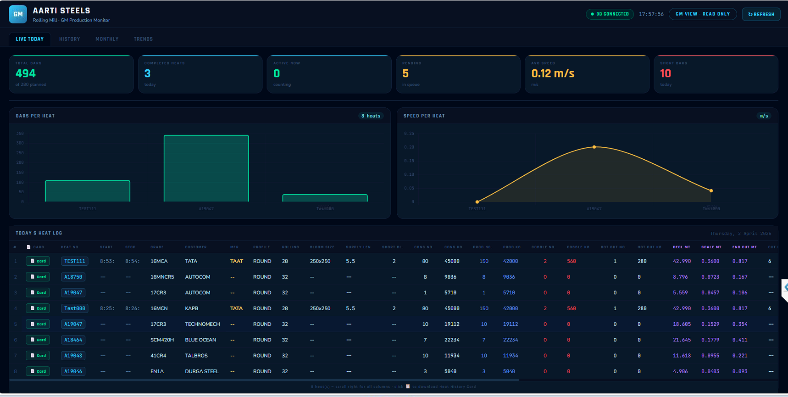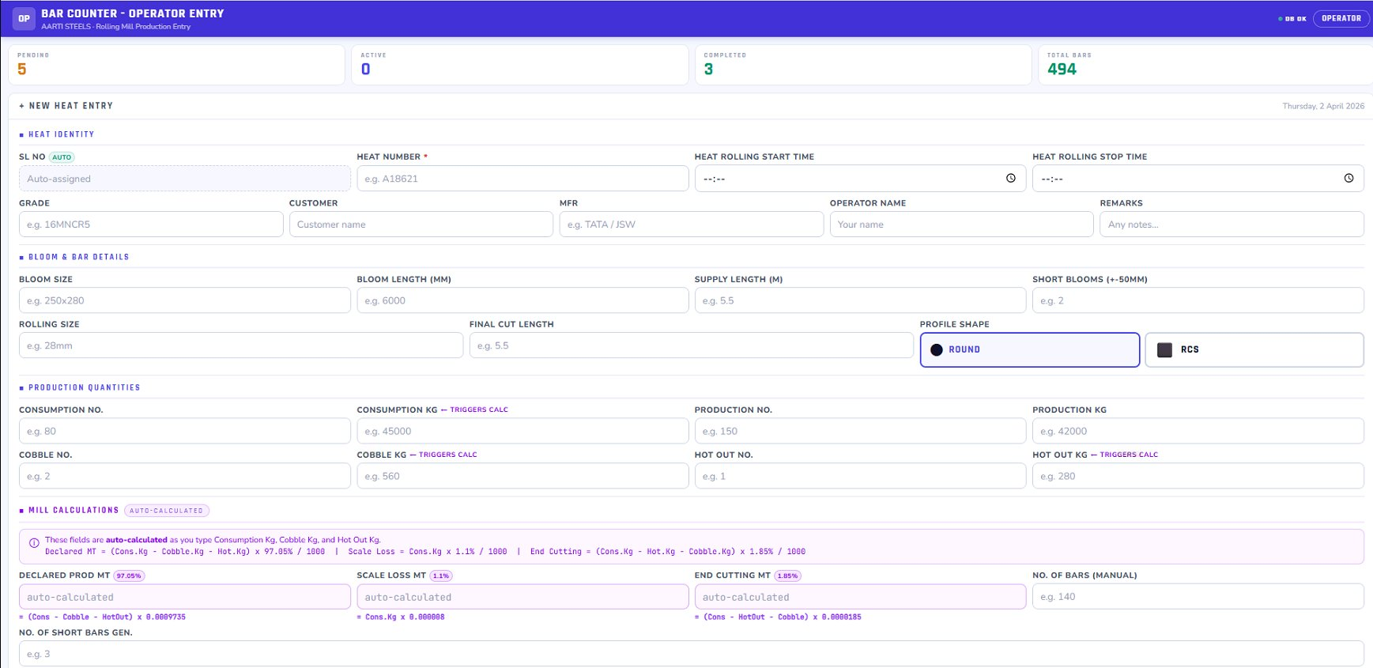
Figure 2 — Bar Counter Operator Entry form showing a new heat entry with all section fields

3.1 Accessing the Interface
- Open a web browser on the Operator workstation.
- Navigate to the Operator Entry URL (provided by your system administrator, e.g., http://192.168.x.x:5001).
- The interface loads displaying the current shift summary and the New Heat Entry form.

3.2 Shift Summary Bar
At the top of the screen, a summary bar shows running totals for the current shift:
Field / Element | Description
PENDING | Heats entered but not yet started on PP4.
ACTIVE | Heat currently running on PP4 (should be 0 or 1).
COMPLETED | Heats fully processed and saved.
TOTAL BARS | Cumulative bar count across all completed heats this shift.

3.3 Creating a New Heat Entry
Click the + NEW HEAT ENTRY button at the top of the form to open a blank entry. The form is divided into four sections.

3.3.1 Heat Identity
This section captures the unique identification details of the heat:
Field / Element | Description
SL No (AUTO) | Serial number — assigned automatically by the system. Do not edit.
Heat Number * | Mandatory. Enter the heat number from the rolling schedule (e.g., A18621). Must be unique per shift.
Heat Rolling Start Time | Record the actual time rolling began (HH:MM format). Can be updated retroactively.
Heat Rolling Stop Time | Record the actual time rolling ended. Leave blank while the heat is in progress.
Grade | Steel grade being rolled (e.g., 16MNCR5, 17CR3, 16MCN).
Customer | Customer name this heat is produced for.
MFR | Manufacturer / steel maker supplying the blooms (e.g., TATA, JSW).
Operator Name | Name of the operator entering this record.
Remarks | Optional free-text field for any notes relevant to this heat.

⚠ WARNING — Mandatory Field
Heat Number is the only mandatory field (marked with *). However, it is strongly recommended that all fields are completed accurately, as they appear verbatim in the official Production Report.

3.3.2 Bloom & Bar Details
This section describes the physical dimensions of the input bloom and output bar:
Field / Element | Description
Bloom Size | Cross-sectional dimensions of the input bloom in mm (e.g., 250x280 or 250x250).
Bloom Length (mm) | Length of each input bloom in millimetres (e.g., 6000 mm).
Supply Length (m) | Target finished bar supply length in metres (e.g., 5.5 m).
Short Blooms (+/-50mm) | Number of blooms that fall within ±50 mm of the standard length.
Rolling Size | Finished bar diameter in mm (e.g., 28mm, 32mm).
Final Cut Length | Actual cut length of finished bars in metres.
Profile Shape | Toggle between ROUND (circular cross-section) and RCS (rectangular/square). Click the appropriate button to select.

3.3.3 Production Quantities
Enter the raw quantity figures for this heat. Fields marked TRIGGERS CALC will automatically compute derived values in the Mill Calculations section below when you enter them.
Field / Element | Description
Consumption No. | Number of input blooms consumed.
Consumption KG | Total weight of consumed blooms in kg. TRIGGERS CALC — updates Declared MT, Scale Loss MT, End Cutting MT.
Production No. | Number of finished bars produced.
Production KG | Total weight of finished bars in kg.
Cobble No. | Number of cobbled (defective/scrapped) bars.
Cobble KG | Total weight of cobbled bars in kg. TRIGGERS CALC — updates Scale Loss MT.
Hot Out No. | Number of bars rejected at the hot-out stage.
Hot Out KG | Weight of hot-out bars in kg. TRIGGERS CALC — updates End Cutting MT.

✔ TIP — Auto-Calculation Trigger
You do not need to click any button. As soon as you finish typing in a TRIGGERS CALC field and move to the next field (Tab key or mouse click), the Mill Calculations section updates automatically.

3.3.4 Mill Calculations (Auto-Calculated)
These fields are computed automatically based on the formulae shown on-screen. They cannot be edited directly:
Field / Element | Description
Declared Prod MT (97.05%) | Declared production in metric tonnes. Formula: (Cons.Kg - Cobble.Kg - HotOut.Kg) x 0.9705 / 1000
Scale Loss MT (1.1%) | Estimated scale loss. Formula: Cons.Kg x 0.0011
End Cutting MT (1.85%) | Estimated end cutting loss. Formula: (Cons.Kg - HotOut.Kg - Cobble.Kg) x 0.00185
No. of Bars (Manual) | Optional manual override for the bar count. Normally left blank (system uses PP4 camera count).
No. of Short Bars Gen. | Number of short bars generated during this heat.

ℹ NOTE — Percentage Factors
The percentage factors shown (97.05%, 1.1%, 1.85%) are configured per plant standard. Contact your system administrator if these need to be adjusted for a specific product grade.

3.4 Saving a Heat Entry
- Review all fields for accuracy.
- Scroll to the bottom of the form and click the SAVE / SUBMIT button.
- A success notification appears confirming the heat has been saved.
- The new heat immediately appears as PENDING in both the Shift Summary Bar and the PP4 Heat Queue.

⚠ WARNING — Duplicate Heat Numbers
If you attempt to save a heat with a Heat Number that already exists in the current shift, the system will display an error and prevent saving. Verify the rolling schedule and enter a unique heat number.

3.5 Editing an Existing Heat Entry
Completed heat entries can be edited up until the point the shift report is locked:
- Locate the heat in the COMPLETED list below the entry form.
- Click the heat row to open it in edit mode.
- Modify the required fields.
- Click UPDATE to save changes. Changes are immediately reflected in the Production Report.

⚠ WARNING — Report Locking
Once a shift report is finalized by a supervisor, heat entries become read-only. Contact the supervisor to unlock if corrections are needed.

4. Module C — Rolling Mill Production Report
The Rolling Mill Production Report module generates the official daily production report for Aarti Steel Limited. It aggregates data from the PP3 database across all heats and presents it in a structured tabular format that can be exported to Excel or printed as a PDF.
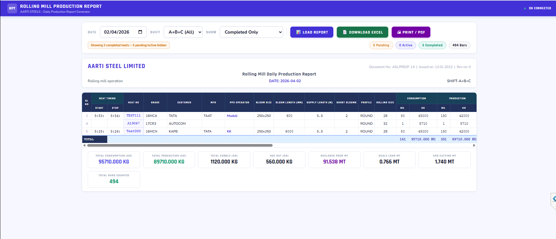
Figure 3 — Rolling Mill Production Report for 02/04/2026, A+B+C Shift, showing 3 completed heats and 494 total bars

4.1 Accessing the Report Module
- Open a web browser and navigate to the Report URL (e.g., http://192.168.x.x:5002).
- The DB CONNECTED indicator in the top-right corner must show green before loading any report.

4.2 Loading a Report
Use the filter bar at the top to select the report parameters:
Field / Element | Description
DATE | Select the production date using the date picker. Defaults to today.
SHOW | Filter the displayed heats: Completed Only (default), All Heats (includes pending and active), or Active Only.

- Set the Date, Shift, and Show filters as required.
- Click the LOAD REPORT button (purple).
- The report generates and displays below the filter bar.

The status bar below the filters confirms how many heats match the selection (e.g., "Showing 3 completed heats — 5 pending/active hidden").

4.3 Report Summary Badges
Four colored badges provide a quick shift summary:
Field / Element | Description
Pending (orange) | Heats entered but not yet completed.
Active (blue) | Heat currently running.
Completed (green) | Heats fully processed and counted.
Total Bars (grey) | Total bar count across all displayed completed heats.

4.4 Production Report Table
The main table lists one row per completed heat with the following columns:
Field / Element | Description
SL No | Sequential serial number within the report.
Heat Timing — Start / Stop | Actual rolling start and stop times for this heat.
Heat No | Heat identifier (clickable to open the heat entry in Module B).
Grade | Steel grade.
Customer | Customer name.
MFR | Steel manufacturer.
PP3 Operator | Operator who entered the heat record.
Bloom Size | Input bloom cross-section (mm x mm).
Bloom Length (mm) | Input bloom length.
Supply Length (m) | Finished bar supply length.
Short Blooms | Count of short blooms.
Profile | ROUND or RCS.
Rolling Size | Finished bar diameter (mm).
Consumption — No. / KG | Count and weight of consumed blooms.
Production — No. / KG | Count and weight of finished bars.

The TOTAL row at the bottom of the table sums all quantities. The Summary Cards below the table show:
- Total Consumption (KG)
- Total Production (KG)
- Total Cobble (KG)
- Hot Out (KG)
- Declared Prod MT
- Scale Loss MT
- End Cutting MT
- Total Bars Counted

4.5 Exporting the Report

4.5.1 Download to Excel
- Click the DOWNLOAD EXCEL button (green).
- A .xlsx file is downloaded to your browser's default Downloads folder.
- The Excel file contains the full heat table on Sheet 1 and the summary totals on Sheet 2.

4.5.2 Print or Save as PDF
- Click the PRINT / PDF button (red).
- Your browser's print dialog opens. The report is pre-formatted for A4/Letter printing.
- To save as PDF, select "Save as PDF" in the Destination drop-down of the print dialog.
- Click Save or Print.

✔ TIP — Official Document
The printed/PDF version of the report includes the Aarti Steel Limited letterhead, Document No. ASL/PRD/F-14, Issue Date, and Revision Number. This is the official daily production record for audit and quality purposes.

5. Troubleshooting
This section addresses the most common issues encountered during daily operation. If an issue is not listed here or cannot be resolved using the steps below, contact SPEAR technical support.

5.1 Bar Count is Not Incrementing
- Check that the Database indicator in the status bar shows Connected (green). If not, see Section 5.2.
- Verify that a heat has been selected from the Heat Queue drop-down and START has been pressed.
- Confirm the GPIO indicator shows Active. If not, the hardware trigger line may be disconnected — check cable connections at the Jetson unit.
- Check that the camera feed is not showing a static/frozen image. If frozen, restart the SPEAR detection service from the Jetson terminal.
- Inspect the physical detection zone — ensure no foreign objects are blocking the camera view.

⚠ WARNING
Never restart the Jetson device mid-heat without first noting the current bar count manually, as the in-memory count buffer will be lost.

5.2 Database Shows Disconnected
- Check that the plant network switch is powered and cables are seated.
- Ping the database server from the Jetson terminal to confirm network connectivity.
- Restart the database connection service: open a terminal on the Jetson and run the reconnect command provided by your IT administrator.
- If the issue persists, contact the IT/network administrator.

5.3 Heat Not Appearing in PP4 Queue after Entry
- Click the REFRESH button in the Heat Queue panel.
- Confirm the heat was saved successfully in the Operator Entry module (check for the success toast notification).
- Verify the Database shows Connected in both modules.
- If still not visible, ask the operator to re-enter the heat and save again.

5.4 System Stuck in Sleep Mode
- Check that the conveyor speed sensor is operational — the Rod Speed field should show a non-zero value when bars are moving.
- Click the SLEEP MODE toggle button in the top-right corner to manually wake the system.
- If the button does not respond, refresh the browser page (F5).
- If the problem recurs frequently, the speed sensor threshold may need recalibration — contact a SPEAR technician.

5.5 Mill Calculations Not Updating
- Confirm you have entered values in Consumption KG, Cobble KG, and Hot Out KG (not just Consumption No.).
- Click away from the field or press Tab to trigger the recalculation.
- Try refreshing the browser page (F5) and re-entering the values.
- Ensure JavaScript is enabled in your browser.

5.6 Report Shows No Data
- Confirm the DB CONNECTED indicator is green on the Report page.
- Check that the DATE selected matches the date heats were entered — the system uses the server date/time.
- Change the SHOW filter from "Completed Only" to "All Heats" to check whether any heats exist for the selected date.
- Verify at least one heat has been fully completed (status DONE) on the PP4 HMI.

5.7 Excel Download Not Working
- Check that your browser is not blocking file downloads — look for a download warning in the browser address bar.
- Try a different browser (Google Chrome is recommended).
- Check the browser's Downloads folder for a partially downloaded file.

6. Glossary of Terms

Term | Definition
Bar Count | The total number of individual steel bars detected by the SPEAR camera system as they pass through the detection zone.
Bloom | A semi-finished steel product (rectangular or square cross-section) that is fed into the rolling mill to produce finished bars.
Bloom Length (mm) | The length of each input bloom before rolling, measured in millimeters.
Cobble | A bar or billet that has been deformed, tangled, or otherwise rendered unusable during the rolling process.
Declared Prod MT | The officially declared production output in metric tons, calculated as (Consumption - Cobble - Hot Out) x 97.05% / 1000.
Detection Zone | The area on the conveyor defined by the two vertical yellow guide lines in the camera feed, within which bars are counted.
End Cutting MT | The estimated weight of bar material lost to end cuts during finishing, expressed in metric tons.
GPIO | General Purpose Input/output — hardware interface on the Jetson device used to receive signals from external sensors (e.g., speed sensors).
Grade | The steel alloy specification of the bars being produced (e.g., 16MNCR5 — manganese-chromium steel, 17CR3 — chromium steel).
Heat | A discrete production run defined by a unique heat number, representing a batch of blooms rolled in sequence.
Heat Number | A unique alphanumeric identifier assigned to each production heat (e.g., A19047). Used to track all associated data from input bloom to finished bar.
Hot Out | Bars that are rejected at the exit of the rolling mill due to surface or dimensional defects detected while still hot.
HMI | Human Machine Interface — the browser-based control panel used by operators to interact with the SPEAR system.
Jetson | NVIDIA Jetson — the edge AI computing device that runs the SPEAR bar detection algorithm and hosts the PP4 Operator HMI.
MFR | Manufacturer — the steel maker supplying the input blooms (e.g., Tata Steel, JSW Steel).
PP3 Database | The production database hosted on the plant network that stores all heat entries, bar counts, and production records.
PP4 Line | The specific rolling mill production line monitored by the SPEAR camera system.
Profile Shape | The cross-sectional shape of the finished bar. ROUND = circular; RCS = rectangular/square.
RCS | Rectangular Cross-Section — a bar profile that is square or rectangular rather than circular.
Rod Speed | The speed at which the rolled bar travels along the conveyor, measured in meters per second (m/s).
Rolling Size | The nominal diameter (for round bars) or cross-section dimension (for RCS bars) of the finished product, in millimeters.
Scale Loss MT | The weight of mill scale (iron oxide flakes) shed from the bar surface during rolling, estimated as Consumption KG x 1.1% / 1000.
Short Bloom | A bloom whose length falls within ±50 mm of the standard bloom length specification.
Sleep Mode | An automatic low-power state entered by the SPEAR system when no conveyor activity is detected, preventing false bar counts.
Supply Length | The target finished bar length to be delivered to the customer, in meters.
Uptime | The duration in hours since the Jetson device was last restarted.

7. Quick Reference Card
Use this section as a rapid daily-use checklist.

7.1 Start-of-Shift Checklist
- Verify Database shows Connected (green) on the PP4 HMI.
- Verify GPIO shows Active (green) on the PP4 HMI.
- Confirm Temp is below 80°C on the PP4 HMI status bar.
- Check that PENDING count is 0 (no orphaned heats from previous shift).
- Confirm the system is awake (not in Sleep Mode) or wake it manually.

7.2 Per-Heat Workflow
- Operator Entry — enter heat details in Module B, click SAVE.
- PP4 HMI — verify heat appears as PENDING in the queue (click REFRESH if needed).
- PP4 HMI — select heat from drop-down, click START.
- Monitor live bar count and rod speed during rolling.
- After rolling completes, click STOP on PP4 HMI.
- Verify bar count is saved (heat moves to DONE).
- Update Stop Time in Operator Entry (Module B) if not auto-populated.

7.3 End-of-Shift Actions
- Confirm all heats show DONE on the PP4 HMI (ACTIVE = 0, PENDING = 0).
- Open Module C (Report), select the shift, click LOAD REPORT.
- Verify all heats and totals are correct.
- Click DOWNLOAD EXCEL or PRINT / PDF to generate the official report.
- File the report as per plant document control procedure.

ℹ NOTE — Support Contact
For technical support, contact the SPEAR system administrator or raise a ticket through your plant IT helpdesk.

AARTI STEEL LIMITED — SPEAR BAR DETECTION & COUNTING SYSTEM — USER MANUAL v2.0
Document No: ASL/SPEAR/UM-01 | Issued: 02 April 2026 | Confidential — Internal Use Only

